**Installing Docker on Windows Server**

* Let’s create a Windows Server 2016 instance in any cloud
* Docs from Microsoft(https://docs.microsoft.com/en-us/virtualization/windowscontainers/deploy-containers/deploy-containers-on-server)
* Launch PowerShell as admin and execute the following commands

Set-ExecutionPolicy unrestricted

[Net.ServicePointManager]::SecurityProtocol = [Net.SecurityProtocolType]::Tls12

Install-Module -Name DockerMsftProvider -Repository PSGallery -Force

Install-Package -Name docker -ProviderName DockerMsftProvider

Restart-Computer -Force

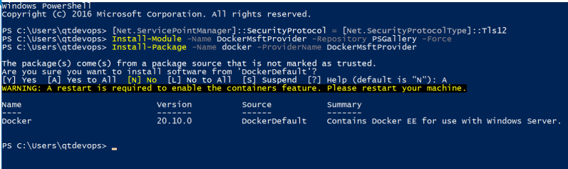

* Post machine restart, Launch PowerShell as admin

docker info

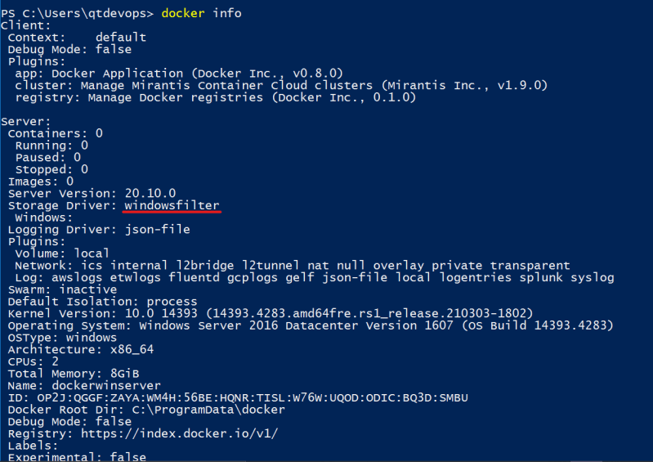

* Now lets try to pull iis server image 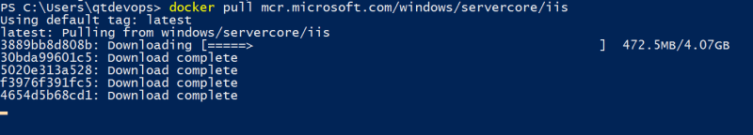
* Now lets run the container 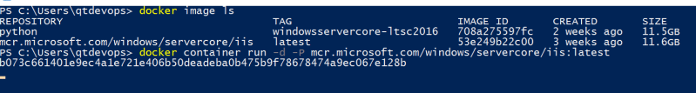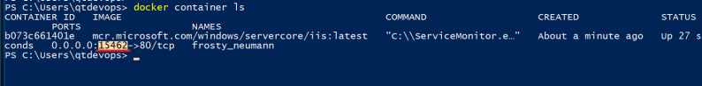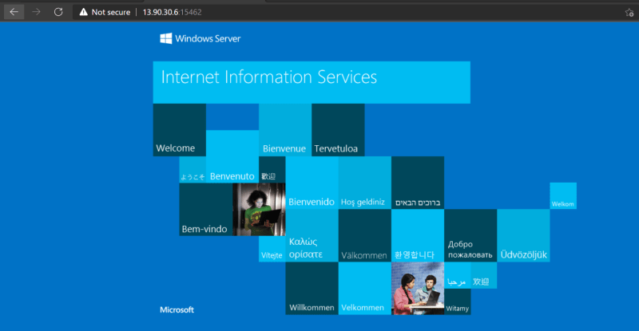
* Run the following command

docker container exec -it <container id/name> powershell

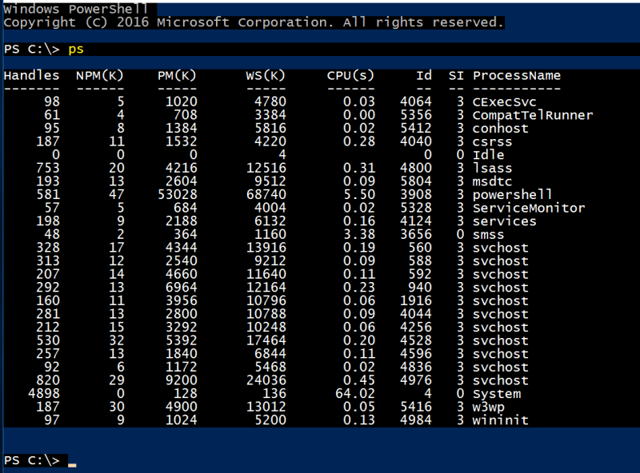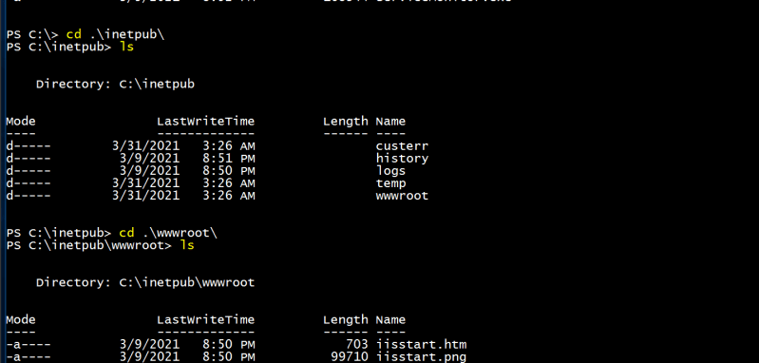

* Launch powershell as admin & then execute docker info